**Pizza Sales SQL QUERIES**

1. Total Revenue of selling Pizza:

Query:

Select sum(total_price) as total_revenue from pizza_sales;

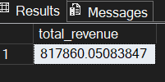

1. Average order values:

Query:

select (sum(total_price)/ count (distinct order_id)) as avg_order_value from pizza_sales;

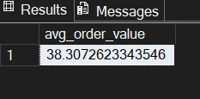

1. Total sold pizzas:

Query:

select sum (quantity) as total_sold_pizzas from pizza_sales;

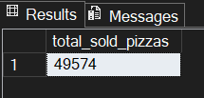

1. Total order placed:

Query:

select count ( distinct order_id) as total_placed_orders from pizza_sales;

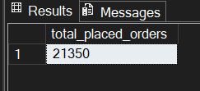

1. Average pizzas per order:

Query:

select cast(cast (sum (quantity) as decimal (10,2))/cast( count (distinct order_id)

as decimal(10,2)) as decimal (10,2)) as avg_pizzas_per_orders from pizza_sales;

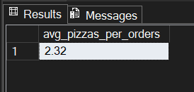

1. Daily Trend for total order:

Query:

select datename( DW, order_date) as order_day, count (distinct order_id) as total_orders from pizza_sales group by

datename (dw, order_date);

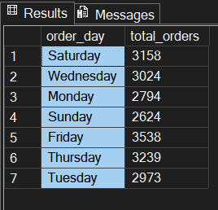

1. Hourly Trend for total order:

Query:

select datepart( hour, order_time) as ordered_hour, count (distinct order_id) as total_orders from pizza_sales group by

datepart (hour, order_time)

order by datepart(hour, order_time);

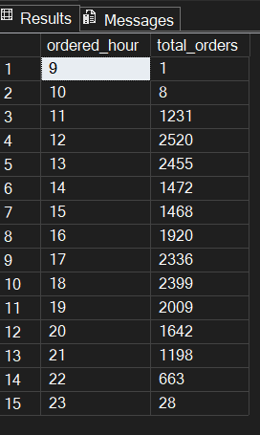

1. Percentage the total sales of pizza category:

Query:

select pizza_category, sum (total_price) * 100 / (select sum(total_price) from pizza_sales) as PCT from pizza_sales

group by pizza_category;

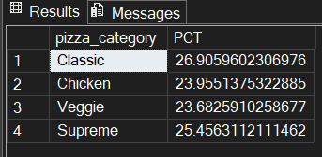

1. Percentage the total sales of pizza size:

Query:

select pizza_size,cast( sum (total_price)*100 / (select sum(total_price) from pizza_sales)

as decimal (10,2)) as PCT from pizza_sales

group by pizza_size

order by PCT;

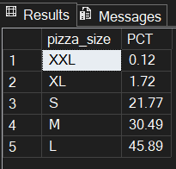

1. Total pizza sold by pizza Category:

Query:

select pizza_category, sum ( quantity) as total_sold_pizza from pizza_sales

group by pizza_category;

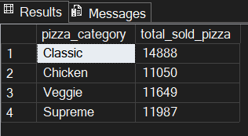

1. Total pizza sold by pizza Category:

Query:

select pizza_category, sum ( quantity) as total_sold_pizza from pizza_sales

group by pizza_category;



1. Top 5 best seller pizzas:

Query:

select top 5 pizza_name, sum(quantity) as total_sold_pizzas from pizza_sales group by pizza_name order by total_sold_pizzas

desc;

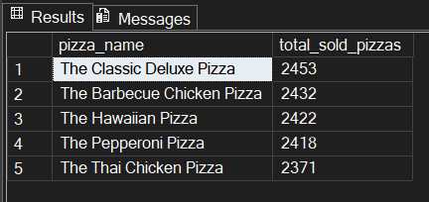

1. Top 5 worst seller pizzas:

Query:

select top 5 pizza_name, sum(quantity) as total_sold_pizzas from pizza_sales group by pizza_name order by total_sold_pizzas

;

